Q.1 Object-oriented Programming uses the concept of objects and classes. It binds data and functions together as a single unit. Class is an instance for creating objects.

Q2.1.Inheritance is the property that inherits properties of one class to another class.We use super() keyword to inherit the properties

2. Encapsulation-Wrapping up of data members and member functions together ex. class is a single unit with access mode private. It helps to hide data and keeps them safe from outside attention.

3. Polymorphism- is the ability to exist in many forms.ex:’+’ is used for both addition and concatenation

4.Abstraction-It is the same as data hiding where only essential things are passed to the external world.

Q3.class is a blueprint for creating objects.It binds data and functions together. Class instances have attributes and methods.It is created using keyword class.attributes can be accessed using dot operator

Objects are instance of class. Because they show classes behaviors

Q4. Encapsulation- wrapping up of data members and member functions together ex.class is a single unit with access mode private .It helps to hide data and keeps them safe from outside attention.

Q5. It is the property that inherits properties of one class to another class . Derived class inherit property of its parents class

1.single inheritance: class inherits properties of only one parent class

2. multiple inheritance: child class inherits properties from more than one parent

3.multilevel inheritance :When the class inherits properties form and derived class where derived class inherited its properties from the base class

4. Hybrid inheritance:It is combined of multiple and multilevel inheritance

Q6.Polymorphism is the ability to exist in many forms.

Ex:

class Animal:

def land_animal(self):

print(“it is able to walk on earth”)

class Frog(Animal):

def land_animal(self):

print(“it is able to walk on earth but also can survive in water”)

cl=Animal()

cl2=Frog()

cl.land_animal()

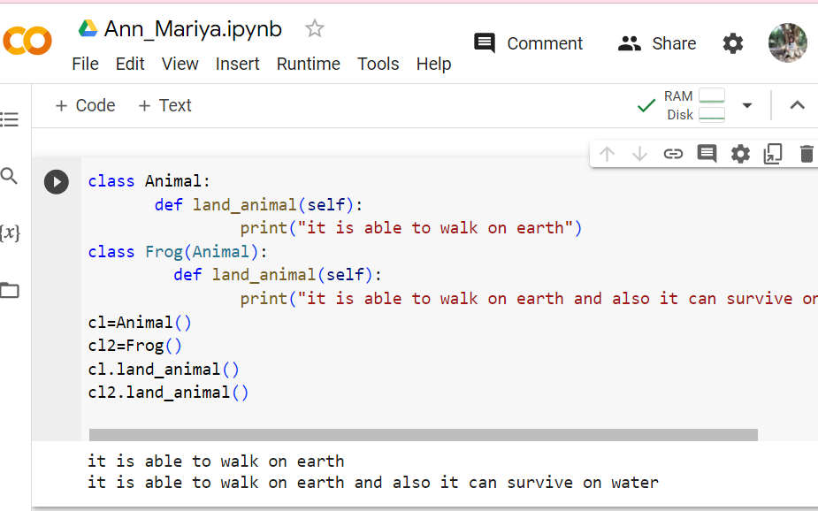

Here there are two functions with same name both get printed.